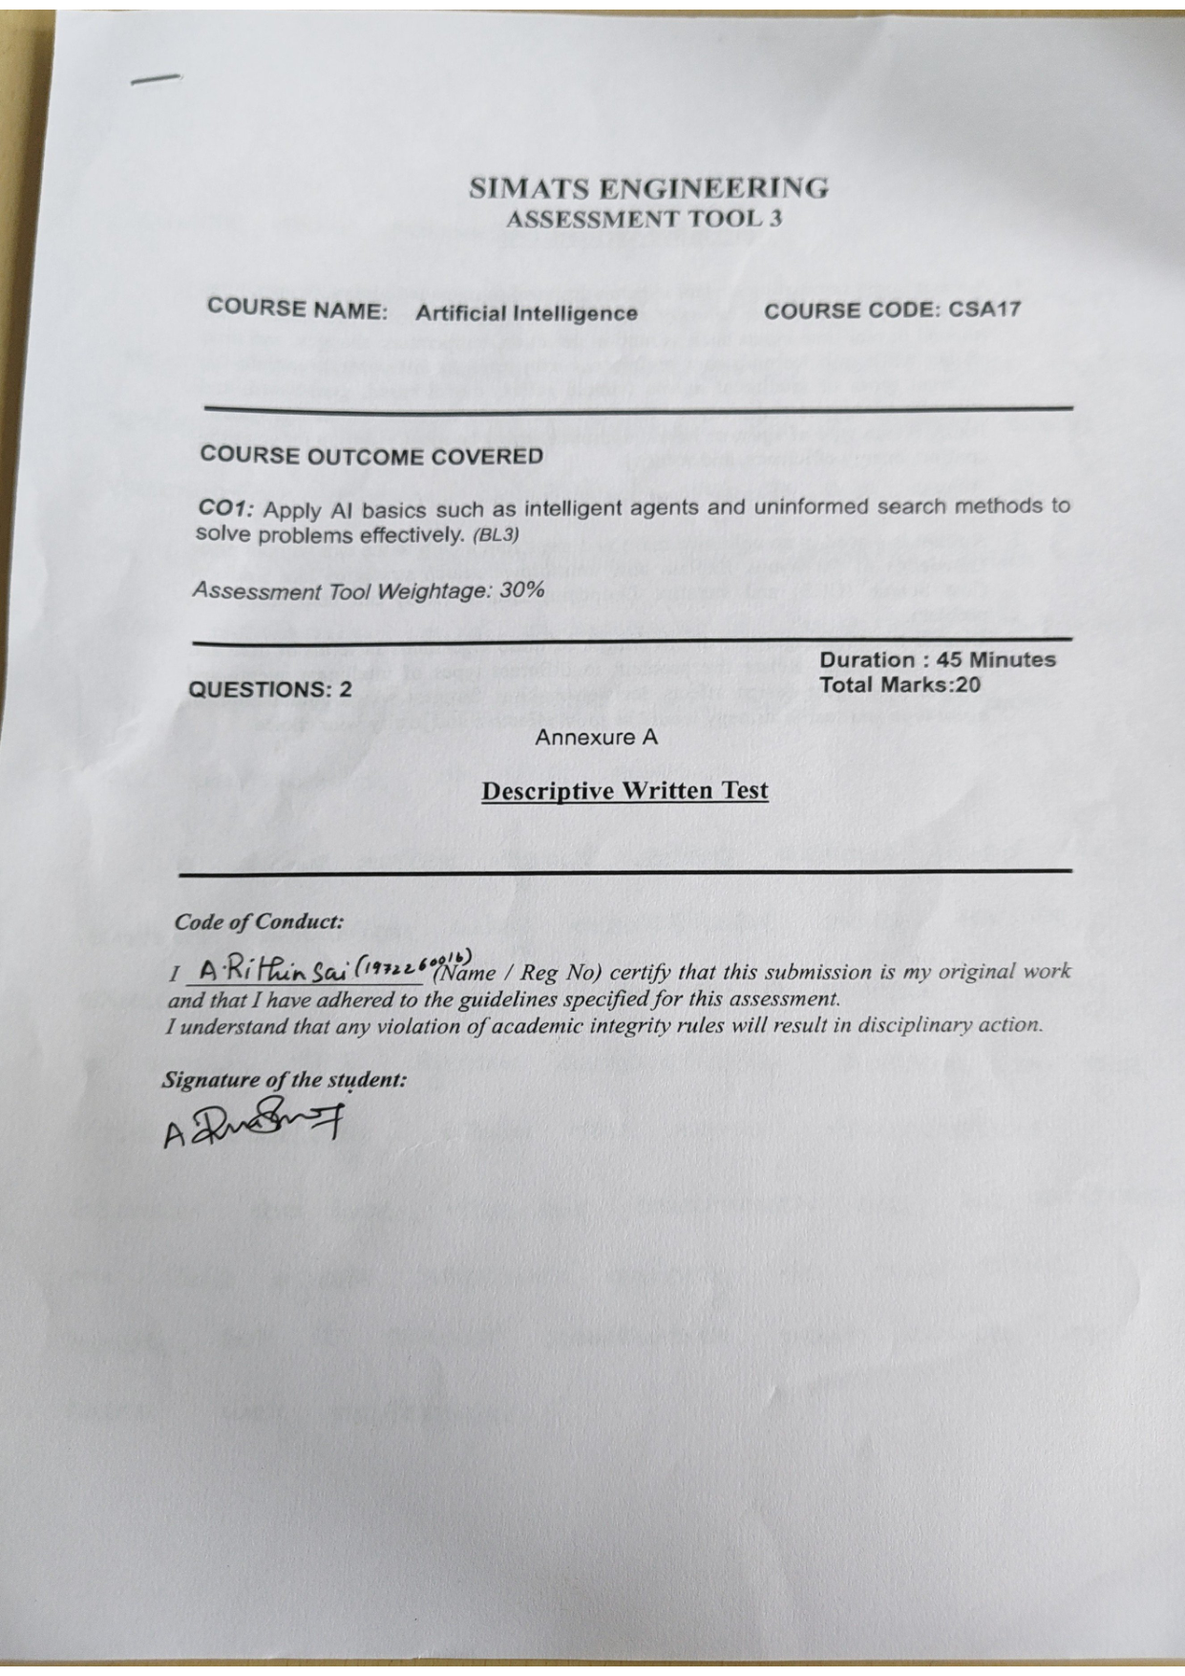

SIMATS ENGINEERING
ASSESSMENT TOOL 3
COURSE NAME: ARTIFICIAL INTELLIGENCE
COURSE CODE: CSA-1709
DONE BY: Rithin Sai A (1972260016)
DESCRIPTIVE WRITTEN TEST

QUESTION 1: SMART HOME AUTOMATION SYSTEM — INTELLIGENT AGENTS
A smart home automation system uses intelligent agents to control lighting, temperature, and security based on user behavior and environmental conditions. The system interacts with the environment through sensors (motion detectors, ambient light sensors, temperature and humidity sensors, door/window magnetic contact sensors, and cameras) and actuators (smart lighting switches, HVAC climate control, automated door deadbolts, smart blinds, and alarm sirens). Its primary objective is to autonomously maximize human comfort, optimize energy efficiency, and maintain high physical security.
1. Simple Reflex Agent
A simple reflex agent operates strictly on the current percept, ignoring percept history, and selects actions based on pre-programmed condition-action rules (IF condition THEN action).
• Function in Smart Home: If a motion sensor detects occupancy in a dark corridor, the agent immediately issues an actuator command to switch on the lights. If no motion is detected for a predefined interval (e.g., 5 minutes), the agent turns the lights off.
• Limitations: It cannot anticipate future states or account for contextual nuances (e.g., whether the user is sleeping, reading, or watching a movie). It fails if the current sensor reading is noisy or if the environment is partially observable.
2. Model-Based Reflex Agent
A model-based agent maintains an internal state (a model of the world) to handle partial observability. It tracks how the environment evolves independently of the agent and how its own actions affect the environment.
• Function in Smart Home: The agent tracks which rooms are currently occupied, thermal retention properties of the house, whether exterior doors and windows are latched, and the status of perimeter security. For example, if a temperature sensor reading drops suddenly while heating is active, the agent infers from its internal model that an exterior window might be open, rather than naively running the heater at maximum capacity.
• Benefit: Enables informed context-aware reasoning even when sensors do not directly capture the entire state of the building simultaneously.
3. Goal-Based Agent
A goal-based agent incorporates explicit goals to guide its decision-making. Rather than simply reacting, it plans sequences of actions that transition the environment from its current state toward desirable goal states.
• Function in Smart Home: The system defines explicit operational goals, such as 'Maintain bedroom temperature at 22°C between 10:00 PM and 6:00 AM', 'Ensure all perimeter locks are engaged by 11:00 PM', or 'Pre-cool the living room before the user arrives home from work at 6:30 PM'.
• Benefit: Highly flexible; if the target schedule or comfort goals change, only the goal specification needs updating without rewriting complex condition-action rules.
4. Utility-Based Agent
A utility-based agent uses a mathematical utility function, U(s), to map states to real-valued scores representing degrees of satisfaction. When multiple competing goals exist, the utility function resolves trade-offs between conflicting criteria.
• Function in Smart Home: Balances thermal comfort against electricity consumption and tariff costs. For instance, during peak electricity tariff hours (e.g., 2:00 PM – 6:00 PM), running the AC at full load maximizes comfort but drastically reduces energy efficiency. The utility-based agent balances comfort and cost by adjusting the thermostat to an optimal 24°C, lowering smart blinds to reduce solar heat gain, and delaying energy-intensive appliances until off-peak hours. Furthermore, if suspicious movement is detected at night, the agent prioritizes security above all other utilities, triggering floodlights and alerting the homeowner.
• Benefit: Provides optimal, multi-objective trade-off balancing across varied environmental scenarios.
5. Learning Agent
A learning agent monitors user behavior and environmental outcomes over time to autonomously improve its operational performance.
• Function in Smart Home: Observes daily routines—such as the user's wake-up time, preferred room temperatures during different seasons, typical lighting levels, and departure/arrival times. It dynamically updates internal models and adapts rules without requiring manual reprogramming.
• Benefit: Transforms the smart home from a static automated system into an adaptive, self-tuning personalized environment.
Justification of the Most Effective Approach (Hybrid Intelligent Agent):
A single agent architecture cannot independently meet all demands of comfort, energy efficiency, and security:
• Simple reflex components are essential for real-time safety and instant responsiveness (e.g., immediate tripping of fire alarms or turning on stairway lights upon motion).
• Model-based components maintain accurate awareness of home occupancy, door/window states, and thermal dynamics despite sensor noise.
• Utility-based components resolve trade-offs between electric utility costs and thermal comfort.
• Learning components ensure continuous self-adaptation to user habits.
Therefore, a Hybrid Intelligent Agent that layers simple reflex actions over a model-based, utility-optimizing, and learning core is the most effective approach for an adaptive, energy-efficient, and secure smart home.
Agent Type | Primary Mechanism | Smart Home Application | Key Strengths & Trade-offs
Simple Reflex | Condition-action rules based on current percept only | Motion-triggered lights, smoke alarm siren | Instant real-time response; fails in partially observable environments.
Model-Based | Internal world state tracking history and dynamics | Occupancy tracking, window open vs AC operation | Handles partial observability; requires accurate state transition model.
Goal-Based | Planning action sequences to satisfy target states | Night-time security lockdown, scheduled pre-cooling | Flexible goal modification; does not handle competing trade-offs naturally.
Utility-Based | Utility function maximizing trade-offs across states | Balancing AC electricity cost vs occupant comfort | Optimal multi-objective decision making; complex utility formulation.
Learning Agent | Feedback evaluation adapting models from experience | Learning wake-up times and temperature preferences | Self-tuning personalization; requires training time and data stability.
Hybrid Agent | Hierarchical integration of reflex, model, utility & learning | Complete autonomous smart home ecosystem | Optimal combination of speed, context-awareness, optimization, and adaptivity.

QUESTION 2: ROBOT FINDING AN EXIT IN AN UNKNOWN MAZE USING UCS AND IDS
When a mobile robot is placed inside an unknown maze, it possesses no prior blueprint of the walls, pathways, or exit location. The robot must utilize its onboard proximity sensors (ultrasonic, LIDAR, or tactile bumpers) to discover legal moves (Up, Down, Left, Right) online. Because heuristic estimates (such as Manhattan distance to an unknown exit coordinate) cannot be computed, the robot must rely on uninformed (blind) search strategies. Two fundamental uninformed algorithms suited for this task are Uniform Cost Search (UCS) and Iterative Deepening Search (IDS).
1. Uniform Cost Search (UCS)
• Mechanism: UCS expands the frontier node with the lowest cumulative path cost g(n) from the start node, managing candidate paths via a Priority Queue (min-heap).
• Function in Maze: If each grid move incurs a uniform cost (e.g., 1 unit), UCS behaves identically to Breadth-First Search (BFS), systematically exploring nodes in concentric rings of equal path distance. If step costs vary (e.g., moving through muddy terrain costs 3 units, smooth tile costs 1 unit, or inclined ramps cost 2 units), UCS guarantees finding the cheapest route to the exit.
• Optimality & Completeness: UCS is complete and optimal provided step costs are strictly positive (step cost ≥ ε > 0).
• Complexity:
- Time Complexity: O(b^(1 + ⌊C*/ε⌋)), where b is the branching factor, C* is the cost of the optimal path, and ε is the minimum step cost.
- Space Complexity: O(b^(1 + ⌊C*/ε⌋)), requiring exponential memory because all generated frontier nodes are stored simultaneously.
2. Iterative Deepening Search (IDS)
• Mechanism: IDS combines the spatial efficiency of Depth-First Search (DFS) with the completeness of Breadth-First Search (BFS). It repeatedly performs Depth-Limited Search (DLS), incrementally raising the depth cutoff limit (limit = 0, 1, 2, ..., d) until the exit is reached.
• Function in Maze: At limit = 1, the robot examines immediate adjacent cells. At limit = 2, it explores paths up to 2 steps away using DFS recursion. It continues incrementing depth until the goal is found at depth d.
• Overhead of Node Regeneration: Although shallow nodes are regenerated across iterations, the geometric growth of search trees means the bottom level dominates: nodes at depth d are generated once, depth d-1 twice, etc. The overhead ratio is approximately b/(b-1), which is negligible (e.g., ~33% for b=4).
• Complexity:
- Time Complexity: O(b^d), asymptotically identical to BFS.
- Space Complexity: O(b·d), requiring only linear memory proportional to maximum search depth, as only the current path and siblings are stored in the recursion call stack.
Algorithm | Time Complexity | Space Complexity | Completeness | Optimality
Uniform Cost Search (UCS) | O(b^(1 + ⌊C*/ε⌋)) | O(b^(1 + ⌊C*/ε⌋)) [Exponential] | Complete (if step cost ≥ ε > 0) | Optimal for arbitrary non-negative costs
Iterative Deepening Search (IDS) | O(b^d) | O(b · d) [Linear Memory] | Complete (finite b) | Optimal for uniform step costs (cost = 1)

Relationship to Intelligent Agent Types & Decision Making:
1. Simple Reflex Agent: Incapable of solving unknown mazes systematically. Without memory or an internal map, it frequently falls into infinite loops or dead ends.
2. Model-Based Agent: Essential for maze exploration. It maintains an internal grid-map (identifying explored cells, walls, and open corridors), preventing redundant loops and backtracking safely.
3. Goal-Based Agent: Formulates search trees directed toward reaching the exit cell, selecting actions that lead to the goal.
Recommendation & Justification of Most Effective Combination:
• For Standard Grid Mazes (Uniform Movement Cost = 1):
The most effective combination is a Model-Based Goal-Based Agent utilizing Iterative Deepening Search (IDS). Embedded robots operate with severely restricted onboard RAM. UCS quickly exhausts robot memory by maintaining exponential frontier queues (O(b^d)). IDS guarantees finding the shallowest, shortest path to the exit while consuming strictly linear space (O(bd)), leaving ample memory for sensor processing.
• For Heterogeneous Mazes (Variable Step Costs / Battery Constraints):
If movement costs vary due to rough terrain, turning friction, or battery drain, Uniform Cost Search (UCS) paired with online local sensing is the mandatory choice, as IDS assumes uniform edge weights and cannot guarantee minimal total cost in variable-weight environments.

CONCLUSION
In Question 1, analyzing intelligent agent architectures demonstrates that a Hybrid Agent—combining reflex speed, model-based context, utility-based optimization, and learning adaptivity—is essential to satisfy the conflicting goals of comfort, energy conservation, and security in a smart home. In Question 2, evaluating uninformed search methods reveals that Iterative Deepening Search (IDS) delivers optimal, complete navigation with minimal linear memory O(bd) for uniform-cost mazes, while Uniform Cost Search (UCS) guarantees minimum-cost paths when terrain difficulties and energy consumption introduce variable step costs.

